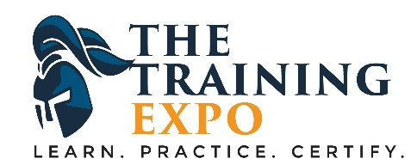
EYELASH TECHNICIAN TRAINING
This course will guide you step-by-step through:
- trends in eyelashes
- types of lash extensions, lifts and perms
- how to safely apply eyelash extensions and what products you need to use
- the tools to use for various eyelash services
- home maintenance for eyelash extensions
- how to properly remove lash extensions
- how to properly apply lash lifts and what products you need to use
- home maintenance for eyelash lifts
- health and safety procedures for lash lifts
- how to properly apply lash perms and what products you need to use
- health and safety procedures for lash perms
- home maintenance for eyelash perms
- how to keep your customer safe
- how to price your services
- how to market your business
PLUS YOU WILL HAVE A 1-DAY HANDS ON WORKSHOP TO DEMONSTRATE YOUR SKILLS. So enroll today by calling 770-471-4819 or send a request from website. Registration is handled online due to COVID-19 precautions.
Tuition: $299.00, this is an accredited program. Take $100, sale ends soon.

